PILAR CORRIAS PRESENTS
JOHN SKOOG
Sent på Jorden and Förår

Private view: Wednesday 21 November, 6-8 pm
Gallery Open: Monday – Friday 10am – 6pm, Saturday 11am – 6pm

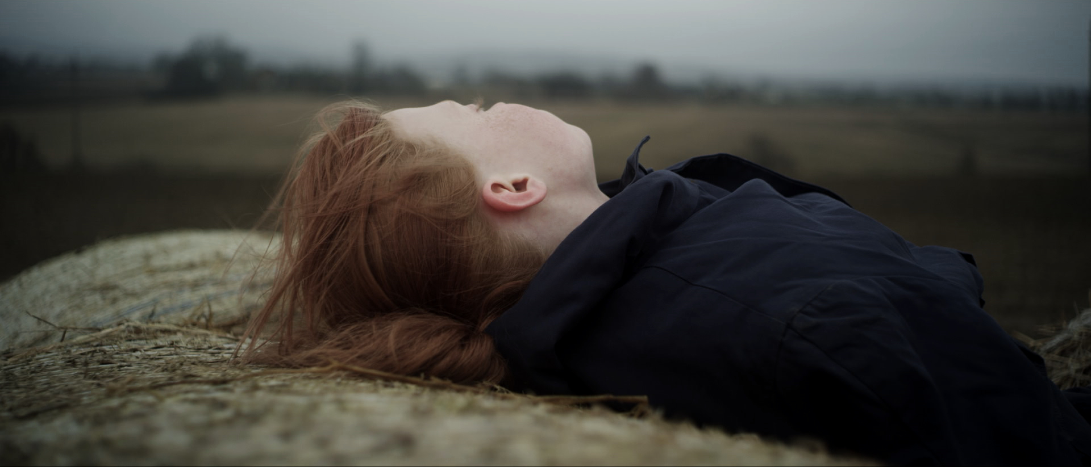
For his first show at Pilar Corrias Gallery, John Skoog (b.1985) will present two new films, Sent på Jorden and Förår.
John Skoog works with film and video. He follows in the tradition of Scandinavian film through the use of stark landscapes and slow pacing. The poetic use of the Swedish landscape and powerful studies of character and emotion evoke memories of film works by cinema greats such as Victor Sjöström and Mauritz Stiller.
Filmed in the south of Sweden in a small town of 900 people the title of the work, Sent på Jorden (Late on Earth) is taken from an acclaimed text by the Swedish poet Gunnar Ekelöf. This beautifully fragmented collection of surrealist writings was written during the poet’s extremely isolated circumstances whilst in Paris 1929-32. During this period the poet was a cultural outsider and his innovative use of language was initially met with little understanding. However his writing has since come to be regarded as one of the most groundbreaking works of the Swedish literature.
Sent på Jorden is filmed entirely at dusk, the time between times. The scenes take place late in the summer, when preparations take place for the long Scandinavian winter. The work presents a transition stage, a series of fragments, where notions of the past and futures collide.
Förår, Skoog’s second work was filmed in the same small town of Kvidinge. Förår delves into the psyche of one of the characters initially introduced in Sent på Jorden. The work focuses on a memory of an event that is revisited. The work is offered as a subtle journey into a place on the edge.
Förår, loosely translates from Swedish as the season ‘Spring’. This space is a time that is looking back to what was and forward to something that we do not yet know will be.

An old-Swedish word, not used anymore, Förår is connected to the seasons in farming. Fore-year, Harvest-year and After-year: Spring, Summer and Autumn/Winter. The connotation of the Swedish word can be more foreboding than its anglicised counter-part. Akin to the feeling that something is to happen but one cannot yet see it.

John Skoog (b. Kvidinge 1985) lives and works in Frankfurt, Germany.

Skoog graduated from the Staedelschule, Frankfurt in 2012.
Selected shows and festivals include: Indielisboa, Lisbon International Film Festival, Lisbon, (2012), Onde, Torino International Film Festival, (2011), Rencontres Internationales: Paris, Centre Pompidou, Paris, (2011), En passant (with et al.*), Schirn Kunsthalle, Frankfurt am Main, (2011), In the absence of Glenn Gould (with Z. Dempster), Ludlow 38, Goethe Institute, New York City, (2008) and PS1 Contemporary Art Center, Long Island City, New York, (2007), Malm1, Malmö Konsthall, Malmö (2004)

For further information please contact Lara Asole on +44 (0)207 323 7000 or lara@pilarcorrias.com

